MOCKITO EX.1
Note:I tried fixing up the errors but it persists
SCREENSHOT
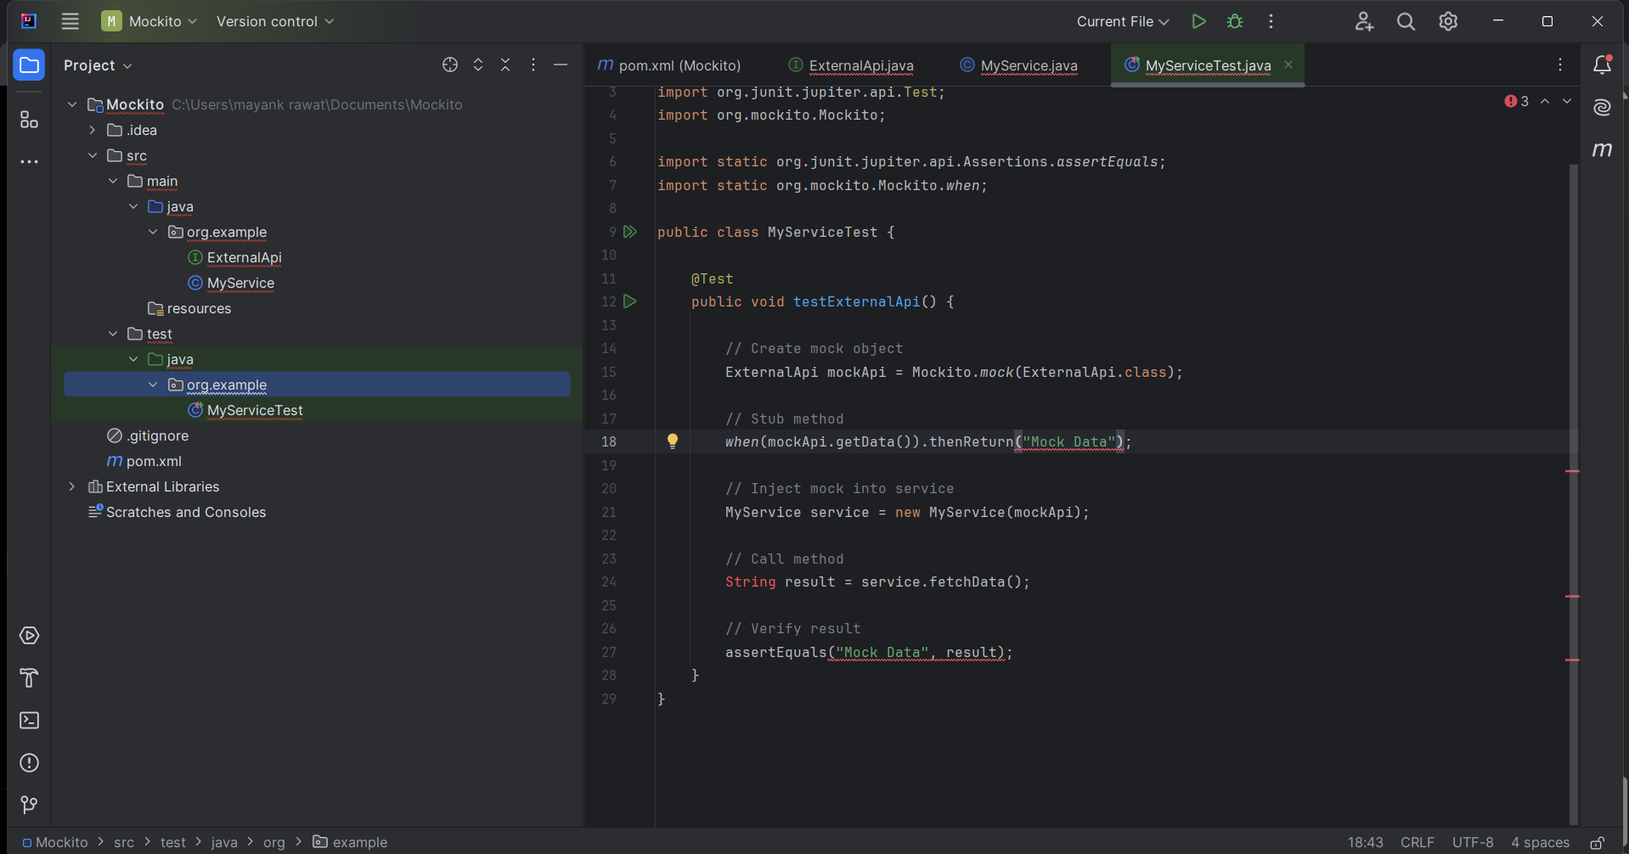
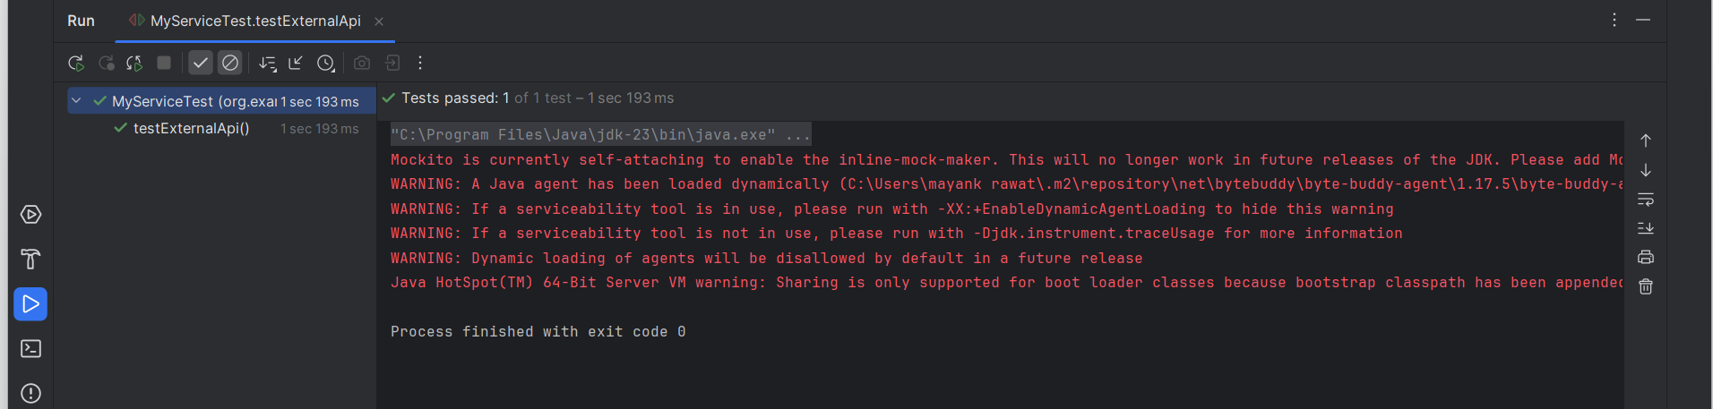

CODE:

ExternalApi

package org.example;

public interface ExternalApi {
String getData();
}

MyService
package org.example;

public class MyService {

private ExternalApi api;

public MyService(ExternalApi api) {
this.api = api;
}

public String fetchData() {
return api.getData();
}
}

MyServiceTest
package org.example;

import org.junit.jupiter.api.Test;
import org.mockito.Mockito;

import static org.junit.jupiter.api.Assertions.assertEquals;
import static org.mockito.Mockito.when;

public class MyServiceTest {

@Test
public void testExternalApi() {

// Create mock object
ExternalApi mockApi = Mockito.mock(ExternalApi.class);

// Stub method
when(mockApi.getData()).thenReturn("Mock Data");

// Inject mock into service
MyService service = new MyService(mockApi);

// Call method
String result = service.fetchData();

// Verify result
assertEquals("Mock Data", result);
}
}

Pom.xml
<?xml version="1.0" encoding="UTF-8"?>
<project xmlns="http://maven.apache.org/POM/4.0.0"
xmlns:xsi="http://www.w3.org/2001/XMLSchema-instance"
xsi:schemaLocation="http://maven.apache.org/POM/4.0.0 http://maven.apache.org/xsd/maven-4.0.0.xsd">
<modelVersion>4.0.0</modelVersion>

<groupId>org.example</groupId>
<artifactId>Mockito</artifactId>
<version>1.0-SNAPSHOT</version>

<dependencies>
<!-- JUnit 5 -->
<dependency>
<groupId>org.junit.jupiter</groupId>
<artifactId>junit-jupiter</artifactId>
<version>5.13.4</version>
<scope>test</scope>
</dependency>

<!-- Mockito -->
<dependency>
<groupId>org.mockito</groupId>
<artifactId>mockito-core</artifactId>
<version>5.18.0</version>
<scope>test</scope>
</dependency>
</dependencies>

<properties>
<maven.compiler.source>22</maven.compiler.source>
<maven.compiler.target>22</maven.compiler.target>
<project.build.sourceEncoding>UTF-8</project.build.sourceEncoding>
</properties>

</project>

Mockito Ex. 2

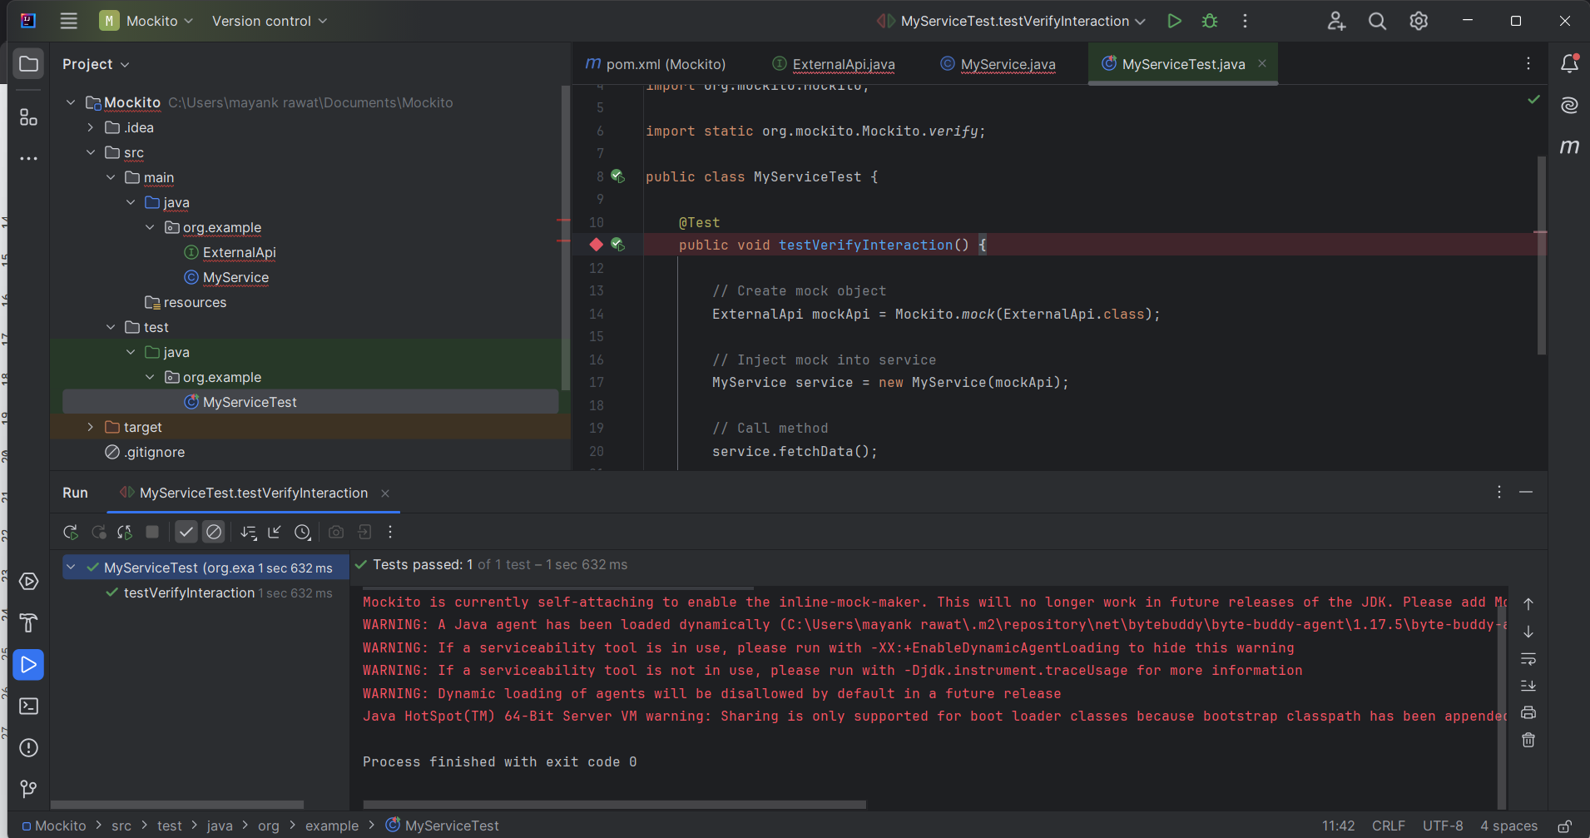

MyServiceTest

package org.example;

import org.junit.jupiter.api.Test;
import org.mockito.Mockito;

import static org.mockito.Mockito.verify;

public class MyServiceTest {

@Test
public void testVerifyInteraction() {

// Create mock object
ExternalApi mockApi = Mockito.mock(ExternalApi.class);

// Inject mock into service
MyService service = new MyService(mockApi);

// Call method
service.fetchData();

// Verify interaction
verify(mockApi).getData();
}
}

